LAB ASSESSMENT 4

1)

CODE:

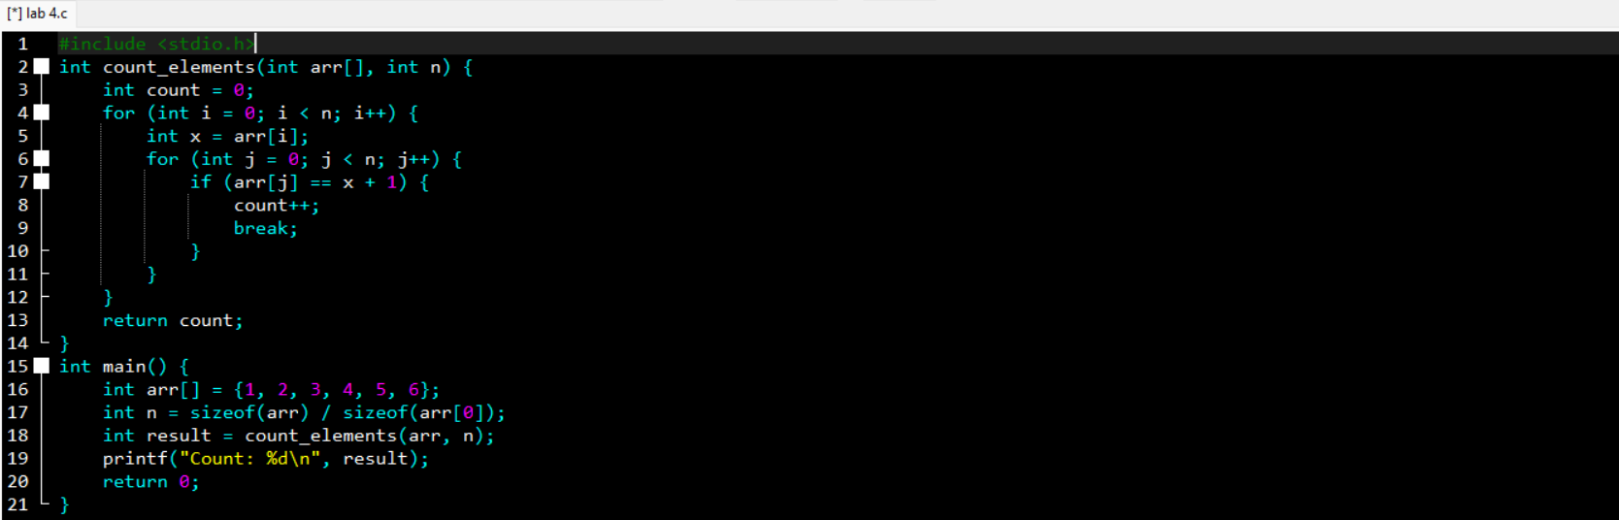

OUTPUT:

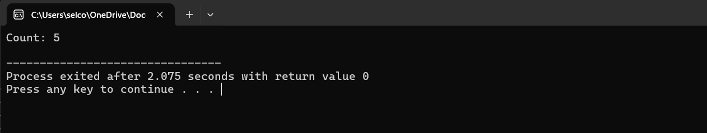

2)

CODE:

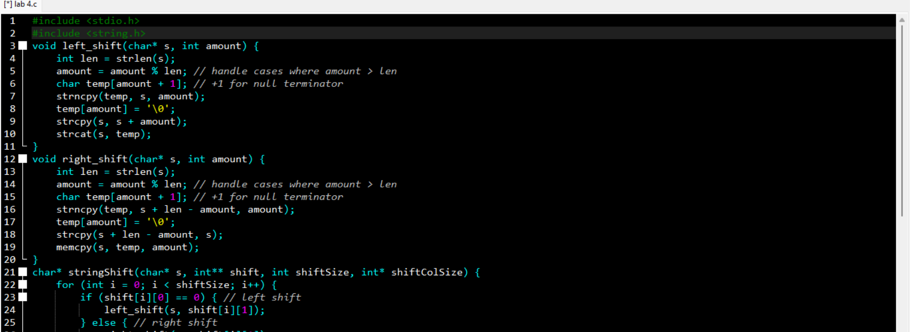

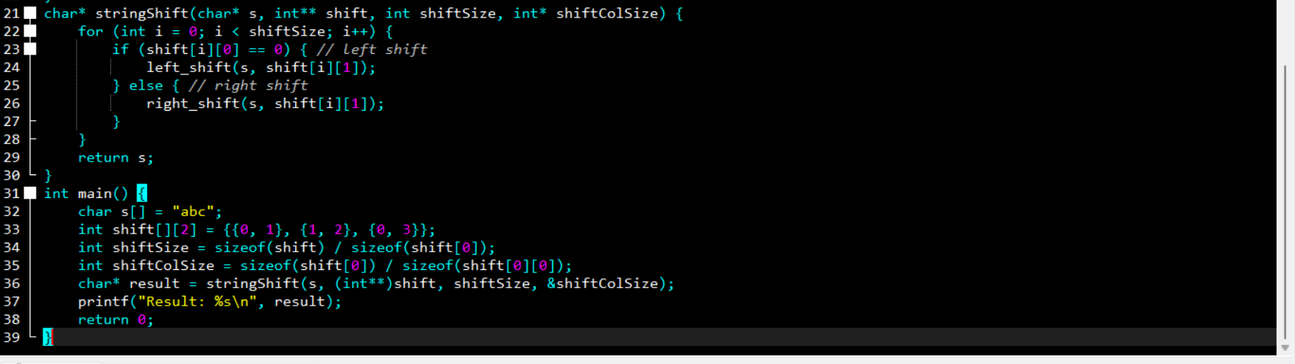

OUTPUT:

4)

CODE:

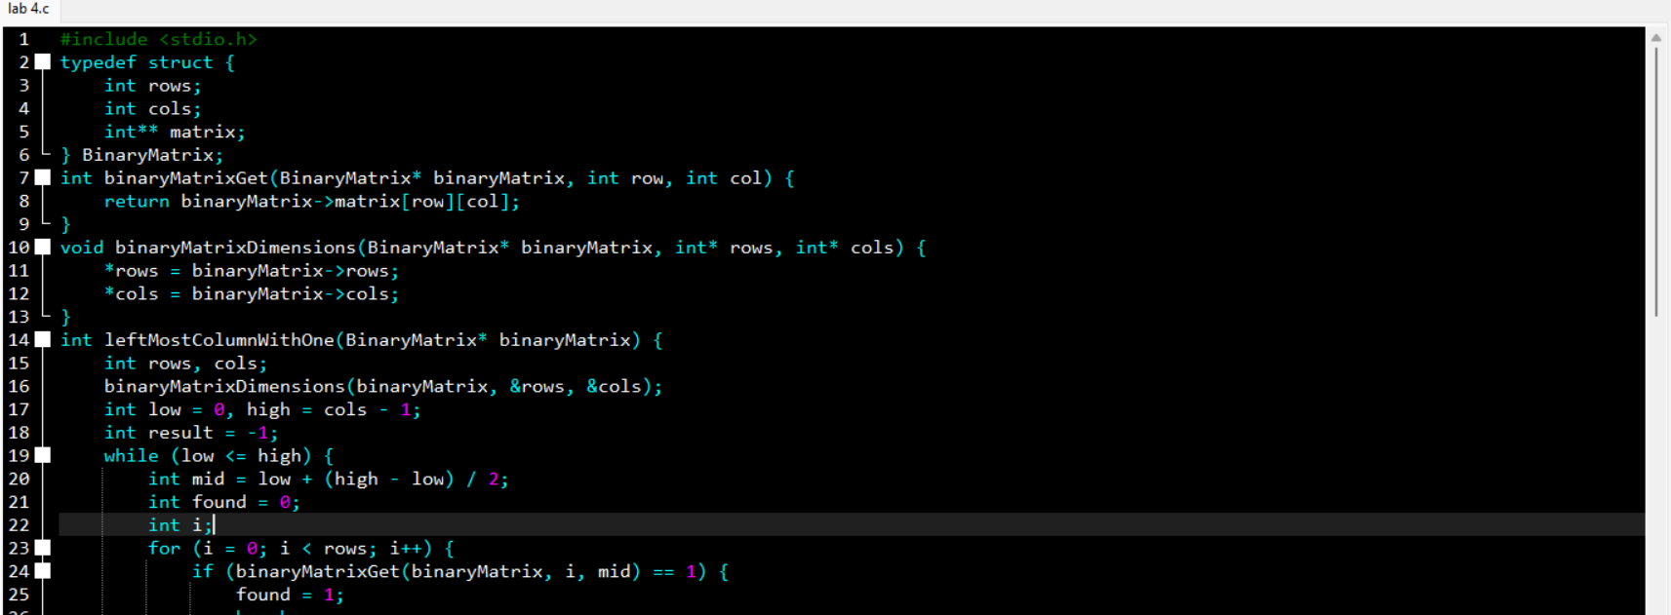

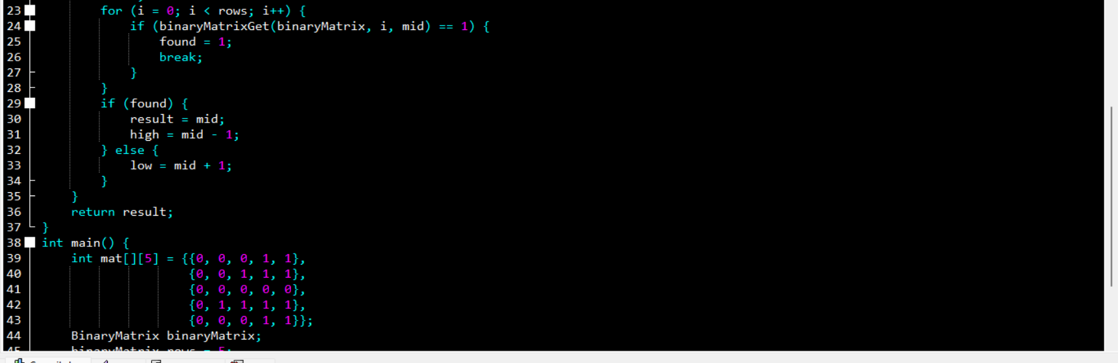

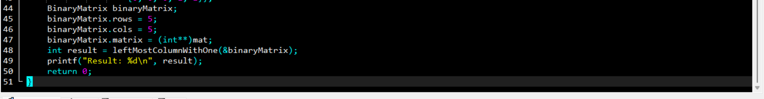

OUTPUT:

5)

CODE:

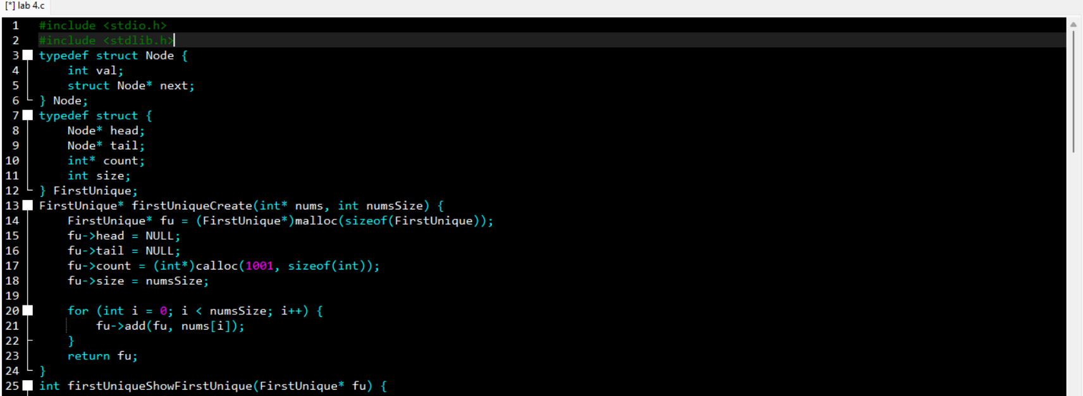

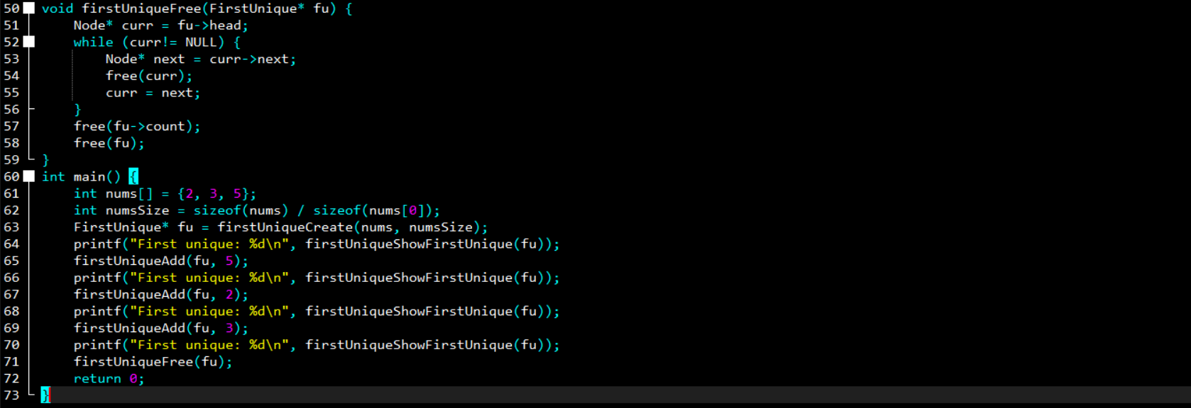

6)

CODE: